The Effect of XYZ on ABC in Function KYZ
(Title of the Paper
(Times New Roman (TNR) 18 pt, Bold, Centered)
(Maximum 15 words, concise and informative)
First Author^{1,a)}, Second Author^{2,b)}, Third Author^{3,c)}, Fourth Author⁴⁾, Fifth Author⁵⁾ (TNR 14)
¹Department of Engineering, Universitas XYZ, Kota ABC, Negara ABC
²Department of Engineering, Universitas YUK, Kota ABC, Negara ABC (TNR 10 Italic)

^{a)}Corresponding author: example@gmail.com
^{b)}example@gmail.com
^{c)}example@gmail.com
(TNR 10)

Abstract. This abstract should briefly summarize the background, purpose, methodology, major findings, and conclusions of the study. It must be self-contained and informative for readers.
(Times New Roman 11 pt, justified, min 100 words and maximum 250 words)

Keywords: Material, lorem, ipsu. Keyword min 3 words and max 5 words

INTRODUCTION (TNR 12)
The introduction presents the background of the study, relevant literature review, research gap, objectives, and significance of the study. Citations should follow APA 7th Edition format, for example:
According to Bandura (1997), individual capacity develops through social learning processes.or
School capacity building requires strong institutional and leadership support (Harris & Jones, 2018).

- Citation must use reference manager such as Mendeley
- Citation style is APA 7th Style.

METHODS
Describe the research type, approach, participants, instruments, data collection, and data analysis techniques. Example:

This study employed a Research and Development (R&D) method using the Borg and Gall model, which was modified into four main stages: (1) preliminary study, (2) model development, (3) expert validation, and (4) effectiveness testing. (1)

RESULTS AND DISCUSSION
Present the research results supported by tables and/or figures, followed by a discussion that relates findings to relevant theories or previous studies.
FIGURE 1.

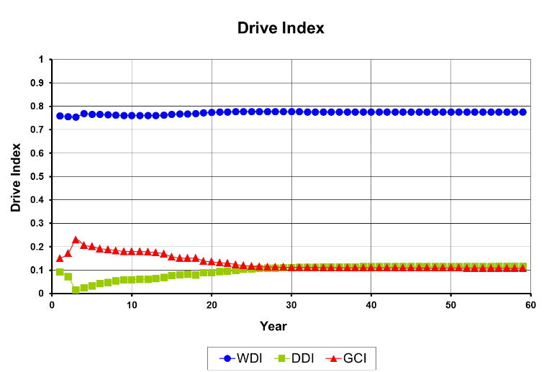
FIGURE 1. Description

TABLE 1.
TABLE 1. Table information
xxxx | xxxx | xxxx | xxxx | xxxx
0 | 0 | 0 | 0 | 0
0 | 0 | 0 | 0 | 0
0 | 0 | 0 | 0 | 0
0 | 0 | 0 | 0 | 0
0 | 0 | 0 | 0 | 0
0 | 0 | 0 | 0 | 0

CONCLUSIONS

Provide conclusions based on the results and discussions. Offer practical recommendations or implications for further research and practice.

Acknowledgments

Acknowledgements can include recognition of financial support, institutional assistance, or individuals who contributed to the research.

References

(Times New Roman 11 pt, hanging indent 0.5 inch, single-spaced)

AOAC. (2002). Guidelines for single laboratory validation of chemical methods for dietary supplements and botanicals. AOAC International, 1–38.
Belitz, H.-D., Grosch, W., & Schieberle, P. (2009). Food Chemistry (4th ed.). Berlin: Springer-Verlag.
Hua, X., & Yang, R. (2016). Enzymes in Starch Processing. In R. L. Ory & A. J. S. Angelo (Eds.), Enzymes in food and beverage processing (pp. 139–170). Boca Raton: CRC Press. http://doi.org/10.1021/bk-1977-0047
OECD-FAO. (2011). OECD-FAO Agricultural Outlook - OECD.
Pratiwi, T. (2014). Uji Aktivitas Ekstrak Metanolik Sargassum hystrix dan Eucheuma denticulatum dalam Menghambat α-Amilase dan α-Glukosidase. Universitas Gadjah Mada.
Setyaningsih, W., Saputro, I. E., Palma, M., & Barroso, C. G. (2016). Pressurized liquid extraction of phenolic compounds from rice (Oryza sativa) grains. Food Chemistry, 192. http://doi.org/10.1016/j.foodchem.2015.06.102
Setyaningsih, W., Saputro, I. E., Palma, M., & Carmelo, G. (2015). Profile of Individual Phenolic Compounds in Rice ( Oryza sativa ) Grains during Cooking Processes. In International Conference on Science and Technology 2015. Yogyakarta, Indonesia.

